|  |
| --- |
|  |
| **REDSYS MANUAL** |
| Versión 1.3 |
|  |
| **Alberto González de Dios** |
| **11/3/2013** |



# INSTALLATION

1. Upload the files from the upload folder to opencart
2. Log into your admin account, go to Extensions > Payment, then install Redsys.
3. Edit Redsys module and configure your Redsys account data: (ID Merchant, Terminal, Password):

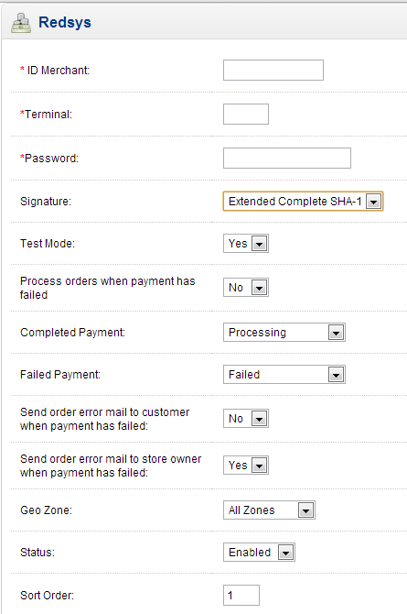

1. Go to admin panel. In System, go to Settings. Edit your store, and go to Mail. Activate the option "New Order Alert Mail".

# REDSYS CHANNEL CONFIGURATION

1. To edit test mode configuration, go to: <https://sis-t.redsys.es:25443/canales/>
2. Configure “Notificación ON-LINE: HTTP”. If you want to also receive confirmation emails, select “ON-LINE: HTTP + Email Comercio”

